Date of preparing: 23/2/2024 Period 68th
Date of teaching: 27/2/2024

UNIT 7: MOVIES
LESSON 2: NEW WORDS, READING
A. OBJECTIVES.
- By the end of the lesson, students will be able to:
1. Knowledge:
- Express opinions and exchange information about movie.
2. Ability:
- Improve speaking skill and read for specific information.
- Develop the ability to communicate and cooperate with their partners, to self - study, to solve problems and other skills.
3. Quality:
- Have positive attitude in English language learning so that they actively participate in all classroom activities, especially with the topic “movies”.
B. TEACHING EQUIPMENT AND LEARNING MATERIALS.
1. Equipments: Bài giảng trình chiếu.
2. Learning materials: student’s book, workbook.
C. PROCEDURES.
I. Warm up. (5’)
a) Objective: To help students relax, and get interested in the topic of the lesson
b) Content: Chatting
c) Product: Students talk about a movie.
d) Organization:
Teacher’s activities | Students’ activities
- Encourage a student to tell the class about an exciting movie he/ she has seen recently.  - Explain some new words if necessary. | - Tell the story of a movie in front of the class.  Possible answer  Titanic is a romantic movie, directed by James Cameron. It stars Leonardo Dicaprio and Kate Winslet. The movie is about the sinking of the ship Titanic on its first voyage. The movie has a sad ending – the Titanic sinks and more than a thousand people die in the disaster.  - Listen to the meanings and copy them down in their notebooks.
II. New lesson:
Activity 1: New words. (13’)
a) Objective: To use some adjectives to describe movies ....
b) Content: Filling in the blanks, talking about kinds of movies ....
c) Products: Students can use a number of adjectives to express opinions about movies.
d) Organization:
Teacher’s activities | Students’ activities
* Presentation:  a. Fill in the blanks with the opposite adjectives. Listen and repeat.  - Pre - teach new words if necessary.  Memory game: What and Where  - Write the words on the board, put each word in a circle.  - Ask students to chorally say the words.  - Rub out the word one by one.  - When all the circles are empty, ask students to say the words again; make sure the students can remember the words in association with the circles.  - Call some students to go on the board and write the words in correct circles again.  - Ask students to fill in the blanks with the opposite adjectives. (sad – funny; boring - exciting for handicapped students)  - Give feedback.  Game: http://worsdwall.net/resource/24225121/Unit 7-Vocabulary-movie adjectives  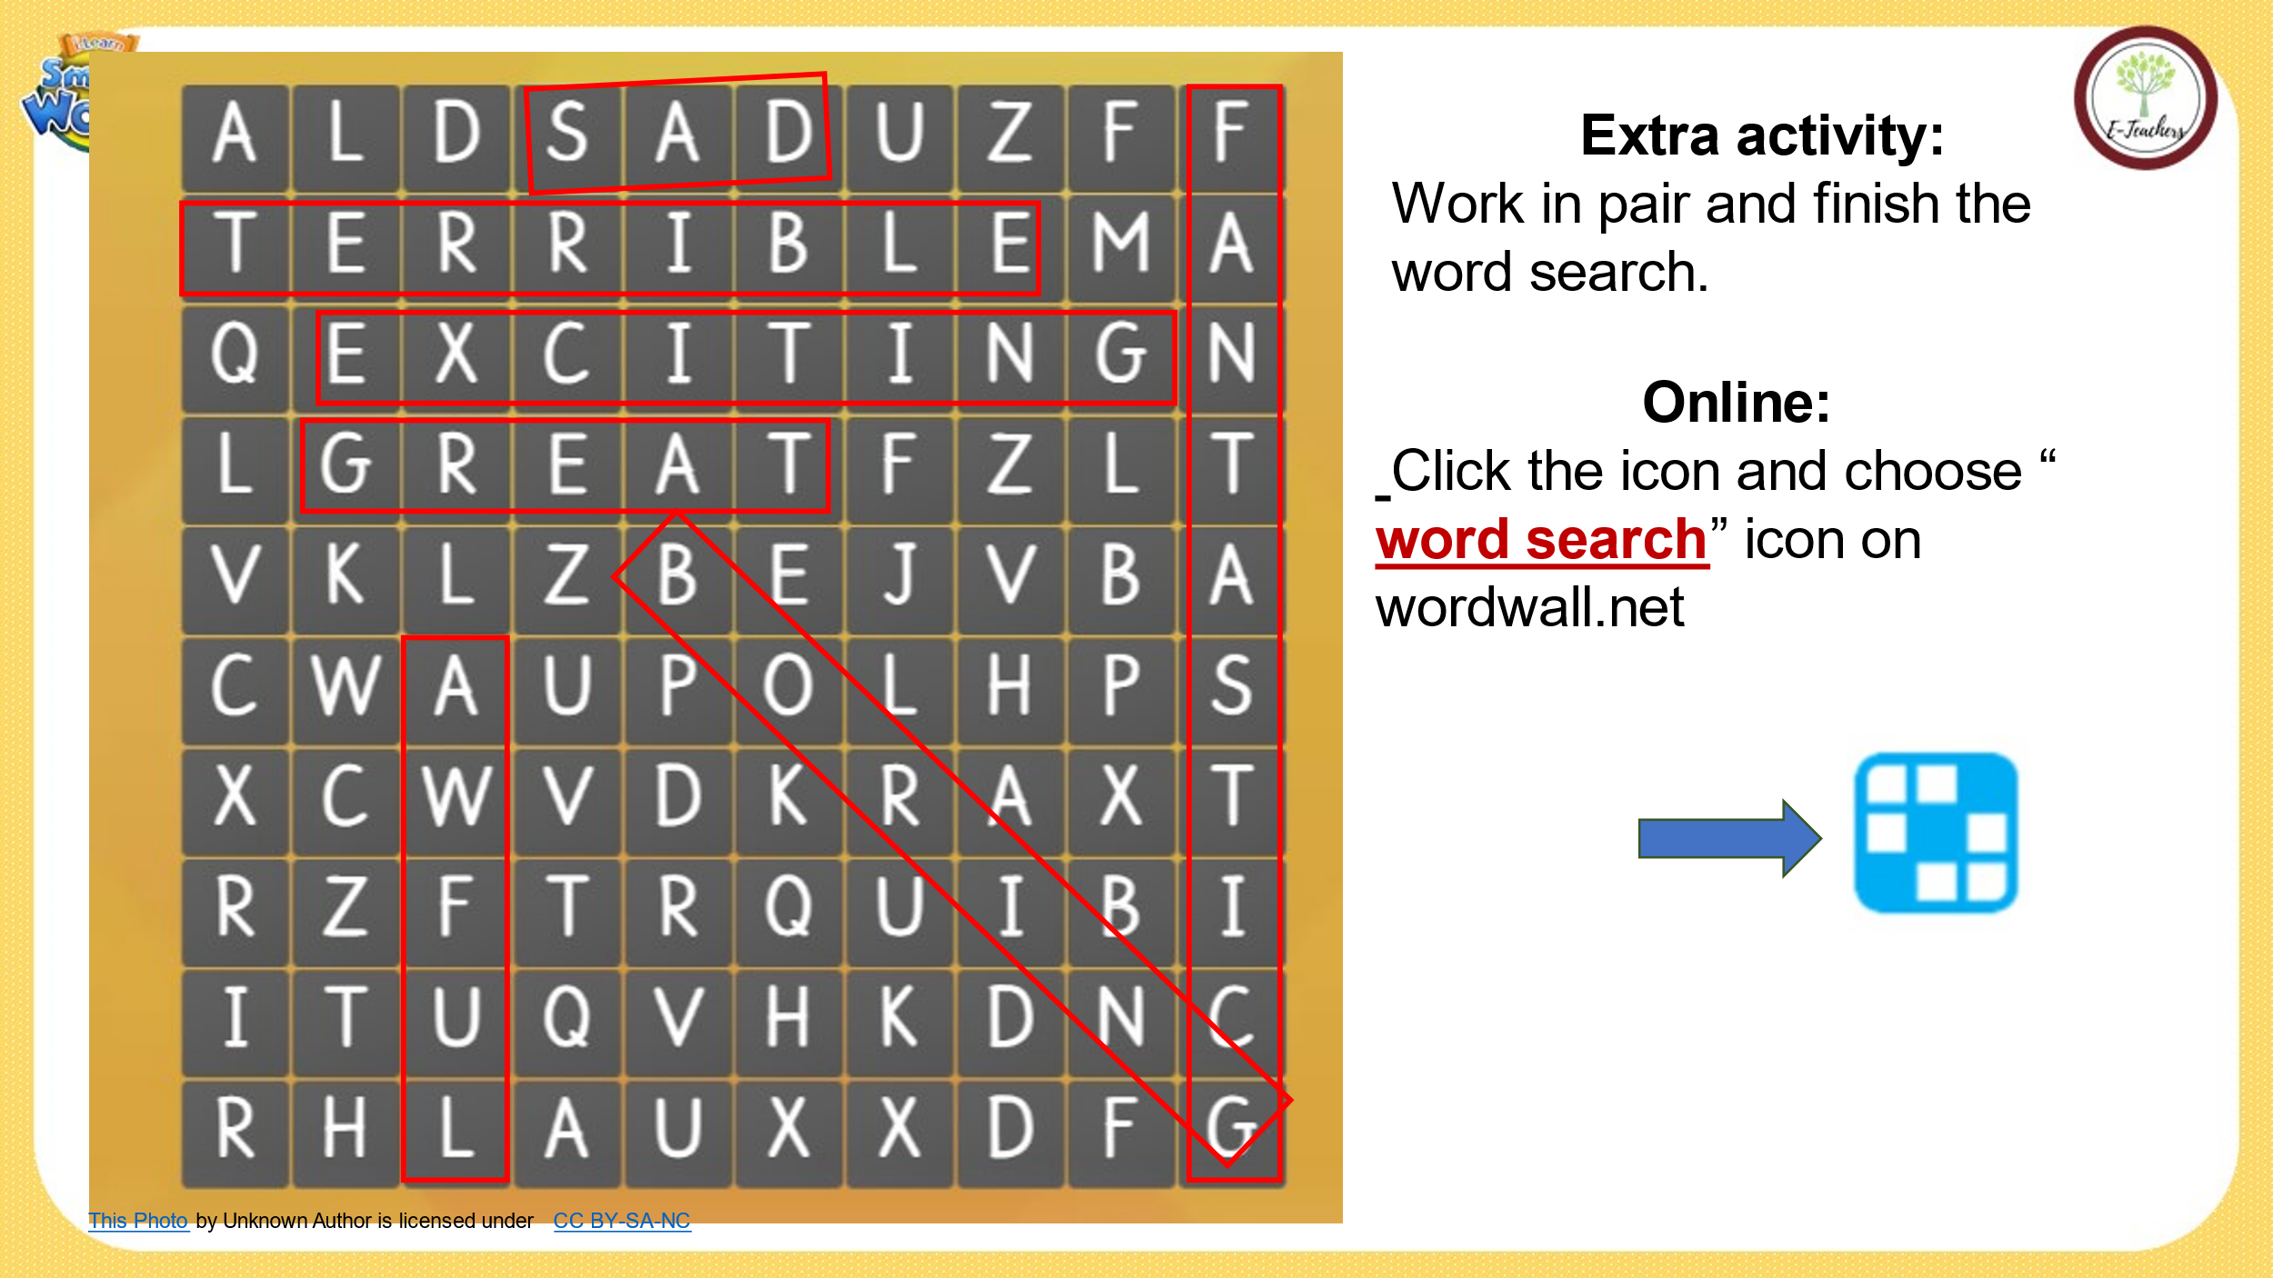*Practice.  b. Talk about kinds of movies you like and don't like using the adjectives.  - Give an example.  - Let students do the speaking task.  - Give feedback and correct the answers. | - New words: terrible, sad, boring, funny, exciting, great, awful.  - Listen carefully and write down new words in their notebooks.  - Repeat the words chorally.  - Say the words again and memorize which word is in which circle.  - Go to the board and write the words in correct circles.  - Work individually to fill in the blanks.  - Give the answers.  Answer keys  terrible - fantastic  sad - funny  awful - great  boring - exciting  - Work in pairs.  - Talk about the kinds of movies they like and don't like using the adjectives  Possible answers  + I think science fiction movies are very great/ useful.  + I think "Crazy Coconut", a romantic comedy, is very funny and entertaining.
Activity 2: Reading. (17’)
a) Objective: To be able read for main ideas and specific information.
b) Content: Underlining the correct final sentences/ reading the reviews again and answering the questions.
c) Products: Students can understand the main ideas of the movie reviews and identify some specific information about them.
d) Organization:
Teacher’s activities | Students’ activities
* Pre - reading:  - Introduce the topic of the reading task.  * While - reading:  a. Tina wrote two movie reviews for her blog. Underline the correct final sentences.  - Have students read the two movie reviews and underline the final sentences.  - Check the answer as a whole class.  - Give feedback.  b. Now, read the reviews again and answer the questions.  - Let students look at the questions, underline the key words  - Have students read the two movie reviews again and answer the questions.  - Give feedback and correct the answers.  * Post - reading:  - Encourage students to give a short review of their favorite movies using the ones they’ve just read as models. | - Read the movie reviews individually  - Share the answers with their partners (in pairs).  - Give the reasons for their choice  Answer keys  - Picture Day: Don't watch this movie.  - Sally's Travels: What a fantastic movie!  - Look at the question’s individual.  - Read them again and answer the questions individually.  - Give answers as a whole class.  Answer keys  1. a sad drama  2. It was boring  3. an action movie  4. It was exciting  5. She was very funny.  - Do an oral movie review (individually) in front of the class.
Activity 3: Writing. (8’)
a) Objective: To be able write for main ideas and specific information.
b) Content: Write again a short favorite movies that they’ve just read.
c) Products: Students can understand the main ideas of the movie reviews and identify some specific information about them.
d) Organization:
Teacher’s activities | Students’ activities
- Have students use post - reading to write a short favorite movies that they’ve just read.  - Have students work in pairs to check each other’s work.  - Have some students share their writing with the whole class (Write on the board).  - Check, correct students’ answers. | - Work individually.  - Work in pairs.  - Write answers.
III. Homework. (2’)
- Prepare: adjectives used to express movies.
- Talk about kinds of movies you like and don't like using the adjectives.
- Do exercises a, b, c on page 40 in the workbook.
- Prepare: Unit 7 - Lesson 2 - Grammar (page 57 - SB).
* Evaluation:
……………………………………………………………………………………….
…………………………………………………………………………………….…………………………………………………………………………………….……

