Date of preparing: 1/3/2024 Period 71st
Date of teaching: 8 /3/2024

UNIT 7: MOVIES
LESSON 3: NEW WORDS, LISTENING
A. OBJECTIVES.
- By the end of the lesson, students will be able to:
1. Knowledge:
- Talk about famous people from history and movies.
- Listen for specific/ detailed information about planning for a trip.
2. Ability:
- Improve speaking, listening skills.
- Develop the ability to communicate and cooperate with their partners, to self-study, to solve problems and other skills.
3. Quality:
- Have positive attitude in English language learning so that they actively participate in all classroom activities; show love/respect for famous people/ heroes from the Vietnamese history.
B. TEACHING EQUIPMENT AND LEARNING MATERIALS.
1. Equipments: Bài giảng trình chiếu.
2. Learning materials: student’s book, workbook.
C. PROCEDURES.
I. Warm up. (5’)
a) Objective: To help students relax and get interested in the topic of the lesson
b) Content: Watching a movie.
c) Product: Students may have general ideas about famous people from history.
d) Organization:
Teacher’s activities | Students’ activities
- Have students watch a short trailer of a historical movie and answer some questions about the movie. (Quang Trung, Trưng Trắc - Trưng Nhị, …)  + Name of the movie.  + Person: (His/ her name).  + famous for. | - Students watch the movie clip and take notes.
II. New lesson.
Activity 1: New words. (15’)
a) Objective: To talk about famous kings, queens, and battles.
b) Content: Circling the correct definitions, talking about famous kings, ...
c) Products: Students have general ideas about some famous people from history in movies.
d) Organization:

Teacher’s activities | Students’ activities
* Presentation:  a. Fill in the blanks. Listen and repeat.  - Pre - teach vocabulary.  - army (n) quân đội  - king (n) nhà vua  - soldier (n) binh lính  - queen (n) nữ hoàng, hoàng hậu  - general (n) vị tướng  - battle (n) trận đánh  - win (v) chiến thắng  - invaders (n) kẻ xâm lược  - Ask students to practice the new words.  - Check students’ pronunciation and understanding of the new vocabulary.  * What and Where (Teacher - whole class).  - Write the words on the board, put each word in a circle.  - Ask students to chorally repeat the English words.  - Rub out the words one by one.  - When all the circles are empty, ask students to repeat again; make sure the students can remember the words in their circles.  - Call some students to go to the board and write the words in their correct circles again.  * Practice:  - Ask students to fill in the blanks. (for handicapped students)  - Correct the answers.  - Play the audio.  b. Circle the correct definitions for the underlined words. Listen and repeat.  - Have students circle the correct definitions...  - Give feedback and correct.  - Play the audio.  c. Talk about famous kings, queens, and battles from your country.  - Elicit some useful information about Ly Thai To from students to set the context of speaking task.  1. Lý Thái Tổ was a famous king.  - Give cues of Lý Thái Tổ.  * Possible cues given:  + Born/ March 8/ 947 AD/ died/ March 31/ 1028.  + The founder/ Lý dynasty of Vietnam.  + Reigned/ 1009/ 1028.  ..........  - Ask student to prepare.  - Give feedback and correct. | - Look at the pictures to give the meaning of new words.  - Write down new words.  - Repeat chorally.  - Work individually.  - Give the answers.  Answers  1. army  2. king  3. queen  4. soldiers  - Listen and repeat.  - Read the sentences carefully and circle the correct definitions.  - Share the answers with their partners.  - Check answers as a whole class.  Answer keys  1. B  2. A  3. A  4. A  - Listen and repeat.  * Lý Thái Tổ was a famous king. He was born on March 8 in 947 AD and died on March 31 in 1028.He was the founder of the Ly dynasty of Vietnam.  He reigned from 1009 to 1028.  - Work individually using the cues.  - Share the ideas with the partners.  - Talking about Ly Thai To in front of the class.
Activity 2: Listening. (15’)
a) Objective: To listen for detailed information about Alexander the Great.
b) Content: Listening and ticking what each person said.
c) Products: Students get some useful knowledge about Alexander the Great, improve listening comprehension.
d) Organization:
Teacher’s activities | Students’ activities
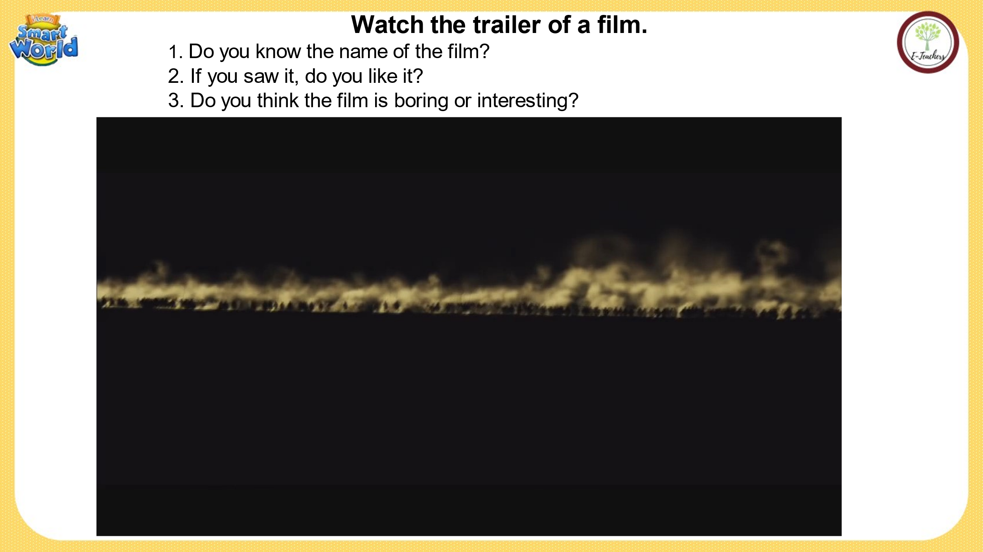* Pre - listening:  - Set the situation by asking students some information about Alexander the Great.  *While - listening:  a. Listen to Jim and Lisa talking about the movie Alexander the Great. Who liked the movie? (For main idea).  - Play the audio (CD2 - 25) twice.  - Play the audio again and check the answer as a whole class.  - Encourage students to say why they choose the answer if there is time (for better students).  b. Now, listen and tick what each person said. while listening.  - Have students look at the table and guess the answers.  - Play the audio (CD2 - 25) twice.  - Play the audio again and check their answer as a whole class.  * Post - listening:  - Encourage students to talk about Alexander the Great. | - Answer the questions.  - Listen the audio and answer the question individually.  - Share their answers with their partners.  - Give the answer.  Answer  Lisa liked the movie (I thought it was great. He was a great king.... I thought it was really interesting.)  - Look at the table and guess.  - Listen and tick what each person said individually.  - Share their answers with the partners  - Tick the answers.  history project movie was boring won many battles great soldiers.  Lisa  Jim  - Talk individually about Alexander the Great by using Fun Facts given.
Activity 3: Speaking. (8’)
a) Objective: To use questions to ask and answers about famous people from movies.
b) Content: Practicing in pairs.
c) Products: Students use some useful language to ask and answer about famous people from movies.
d) Organization:
Teacher’s activities | Students’ activities
- Have students look at the useful language box.  - Have students practice ask and answer.  - Have students work in pairs. | - Work individually.  - Work in pairs.  - Practice asking and answering in pairs in front of the class.
III. Homework. (2’)
- Learn new words by heart.
- Practice talking about famous kings, queens, and battles from your country.
- Listening: Listen and fill in the blanks. (Workbook - page 42)
- Prepare: Unit 7: Lesson 3 - Reading, Speaking (page 60 - SB).
- Study: What do you know about the story of Quang Trung...
* Evaluation:
……………………………………………………………………………………….
………………………………………………………………………………………………………………………………………………………………………………

